**Assignment #4: Illustrate How a VLAN Works**Chandler Ford | October 3, 2018

**What a VLAN is:**

* A Virtual Local Area Network is “set of end stations and switch ports that connect them” ([Source 1](https://bit.ly/2NgZb2l)) on layer 2 that “appear to be on the same LAN despite their geographical distribution” ([Source 2](https://www.techopedia.com/definition/4804/virtual-local-area-network-vlan)).

**What a VLAN is used for:**

* VLAN can “partition [the] network into logical segments” ([Source 1](https://bit.ly/2NgZb2l)) and improve performance and security ([Source 2](https://www.techopedia.com/definition/4804/virtual-local-area-network-vlan)).

**How VLAN works:**

* VLAN works by “applying tags to network packets and handling these tags in networking systems” which makes it look like a single network ([Source](https://en.wikipedia.org/wiki/Virtual_LAN)).

**Example VLAN Setup:**

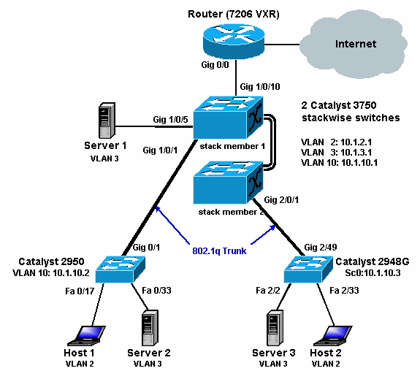

([Source](https://www.cisco.com/c/en/us/support/docs/switches/catalyst-3750-series-switches/45002-intervlan3750-45002.html))